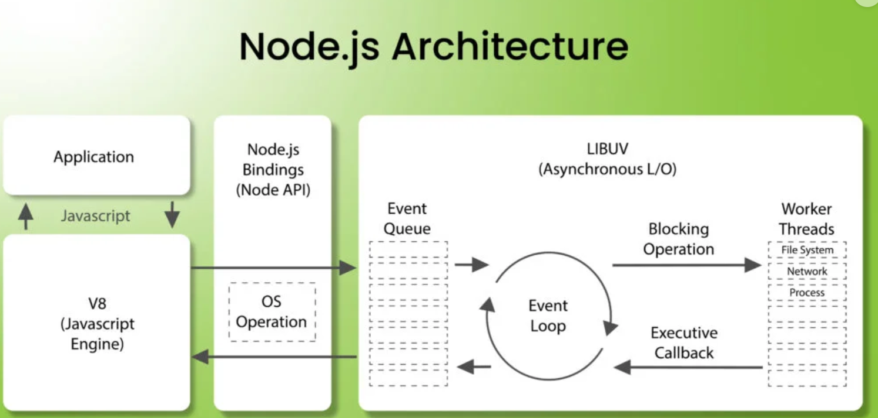

· Node.js uses **asynchronous programming** to handle multiple operations concurrently without creating multiple threads for each task.

· The **event loop** ensures that the application remains responsive, while **worker threads** handle computationally expensive or blocking tasks.

· This architecture makes Node.js highly efficient for **I/O-bound applications** (e.g., web servers, APIs).

### 1. ****Application****

This represents the JavaScript code written by the developer, which interacts with the Node.js runtime.

### 2. ****V8 (JavaScript Engine)****

* **V8** is Google's open-source JavaScript engine, which powers both Chrome and Node.js.
* It executes JavaScript code efficiently by compiling it into machine code.
* In Node.js, V8 provides the environment for running JavaScript outside of the browser.

### 3. ****Node.js Bindings (Node API)****

* Node.js provides additional APIs (e.g., fs for file system operations, http for networking) that extend the capabilities of JavaScript beyond what the browser environment offers.
* These bindings connect JavaScript to underlying system operations like file handling, network requests, or database interactions.

### 4. ****LIBUV (Asynchronous I/O)****

* LIBUV is a library that handles asynchronous operations in Node.js.
* It enables **non-blocking I/O**, meaning operations like file reading/writing or network requests do not block the execution of other code.

#### a) ****Event Queue****

* The **event queue** holds incoming events (e.g., requests, file operations) that need to be processed.
* Events are added to this queue whenever asynchronous operations are initiated.

#### b) ****Event Loop****

* The **event loop** is the heart of Node.js. It continuously checks the event queue for tasks.
* It processes the events by executing their associated callbacks, ensuring smooth and efficient execution.

#### c) ****Blocking Operations and Worker Threads****

* Certain tasks, like file system operations, network requests, or CPU-intensive processes, can block execution.
* **LIBUV** offloads these tasks to a pool of **worker threads** to prevent blocking the event loop.
* Once a blocking operation completes, its result is sent back to the event loop via a callback.

### 5. ****Executive Callback****

* Once a blocking operation completes (handled by worker threads), its associated callback is pushed back to the event loop.
* The callback is then executed in the main thread, continuing the flow of the application.